AWS RDS PostgreSQL Access Guide

Input Guide
This section outlines the input parameters required for provisioning AWS RDS PostgreSQL using the DASH portal. Each parameter includes a description, available options, usage guidance, and notes on valid combinations when applicable.
Input Parameter | Description | Values Provided | Value Guidance | Valid Combinations
region | The region where the database instance will be deployed. | us-east-1, us-west-2, eu-west-1, ap-south-1, ca-central-1, eu-west-2, ap-southeast-1, sa-east-1. | Choose the region that is geographically closest to your end users or services to minimize latency and improve performance. | N/A
db_identifier | A unique name to identify the database instance. | A unique name across all DB instances owned by your account in the current AWS Region. | - The DB instance identifier is case-insensitive, but is stored as all lowercase (as in "mydbinstance")  - Constraints: 1 to 63 alphanumeric characters or hyphens. The first character must be a letter. Can't contain two consecutive hyphens. Can't end with a hyphen. | N/A
db_name | The name of the initial database to be created within the db instance. | Must be a unique database name within the chosen engine. | Allowed characters: letters, numbers, underscores (_).  Must start with a letter. | N/A
db_username | The master username for database administration. | Alphanumeric string. | 1 to 16 alphanumeric characters. The first character must be a letter and should not be set to reserved names such as admin or root. | N/A
db_password | The password associated with the master username for secure access. | Any alphanumeric string. | Set a strong password for the master username.  Minimum constraints: At least 8 printable ASCII characters. Can't contain any of the following symbols: / ' " @ .  Example (valid): MyDBpass#2025 | N/A
db_engine_version | The version of the PostgreSQL database engine. | Versions:  17.2, 17.1, 16.8, 16.7, 16.6, 16.5, 15.12, 15.10. | Choose based on PostgreSQL requirements. | N/A
db_instance_class | The compute and memory capacity allocated for the database instance. | Instance Configuration:  db.t3.micro, db.t4g.micro, db.m5.large, db.m5.xlarge, db.m6g.large, db.m6id.xlarge, db.m7g.large, db.m7g.2xlarge. | Choose based on workload requirements. | N/A
publicly_accessible | Determines whether the database can be accessed from the public internet. | Boolean:  True, False | Choose true if external access is needed, otherwise false. | N/A
db_storage_type | The type of storage allocated for the database. | Storage types:  gp2 (or) gp3 | Choose based on performance and cost requirements. | N/A
db_allocated_storage | The amount of storage (in GB) to be provisioned for the database. | Allowed values (in GB):  20, 40, 60, 80, 100 | Choose based on workload requirements. | N/A
enable_multi-az | Enables high availability by deploying the database in multiple Availability Zones. | Boolean:  True, False. | Choose true for high availability or false for single-AZ. | N/A
deploy_vm | Whether an ec2 instance should also be provisioned to connect to the DB. | Boolean:  True, False | Choose whether to set up a connection to a compute resource for this database. | N/A
instance_type | The size and configuration of the EC2 instance, which defines the amount of vCPUs, memory, and networking performance allocated. | t2.nano, t2.micro, t2.small, t2.medium, t2.large, t2.xlarge, t2.2xlarge, a1.metal, c4.large, c4.xlarge. | Choose based on workload requirements (vCPU, memory). | N/A
os_template | Pre-configured base operating system image (Amazon Machine Image) used for provisioning the EC2 instance. | ubuntu-2204-lts, ubuntu-2004-lts, ubuntu-2404-lts, rhel-9, rhel-8, centos, amazon-linux, amazon-linux-2023. | Choose an OS required for your workload. | N/A
owner | The team or individual responsible for maintaining the resource. | Specify the team name or individual responsible for maintaining the instance. | Provide correct team/individual name. | N/A
application | Associated service or application name for the resource. | Enter the associated service name linked to the instance. | Provide a service name linked to the instance. | N/A
project | Project or initiative name linked to the resource. | Indicate the project or initiative name related to the resource. | Provide the project name related to the resource. | N/A
deployment | The target environment (e.g., development, testing, prod) where the DB will be provisioned. | Define the deployment environment name (e.g., dev, test, prod) | Choose the environment where the database has to be deployed. | N/A
Services expire after 30 days. Create this service now, or schedule for a later date? | RDS PostgreSQL will be deleted 30 days after creation, or it can be scheduled to be created at a later date. | Create Now (or)  Schedule for Later | Choose based on RDS PostgreSQL requirements. | N/A

Sample Input Selection:
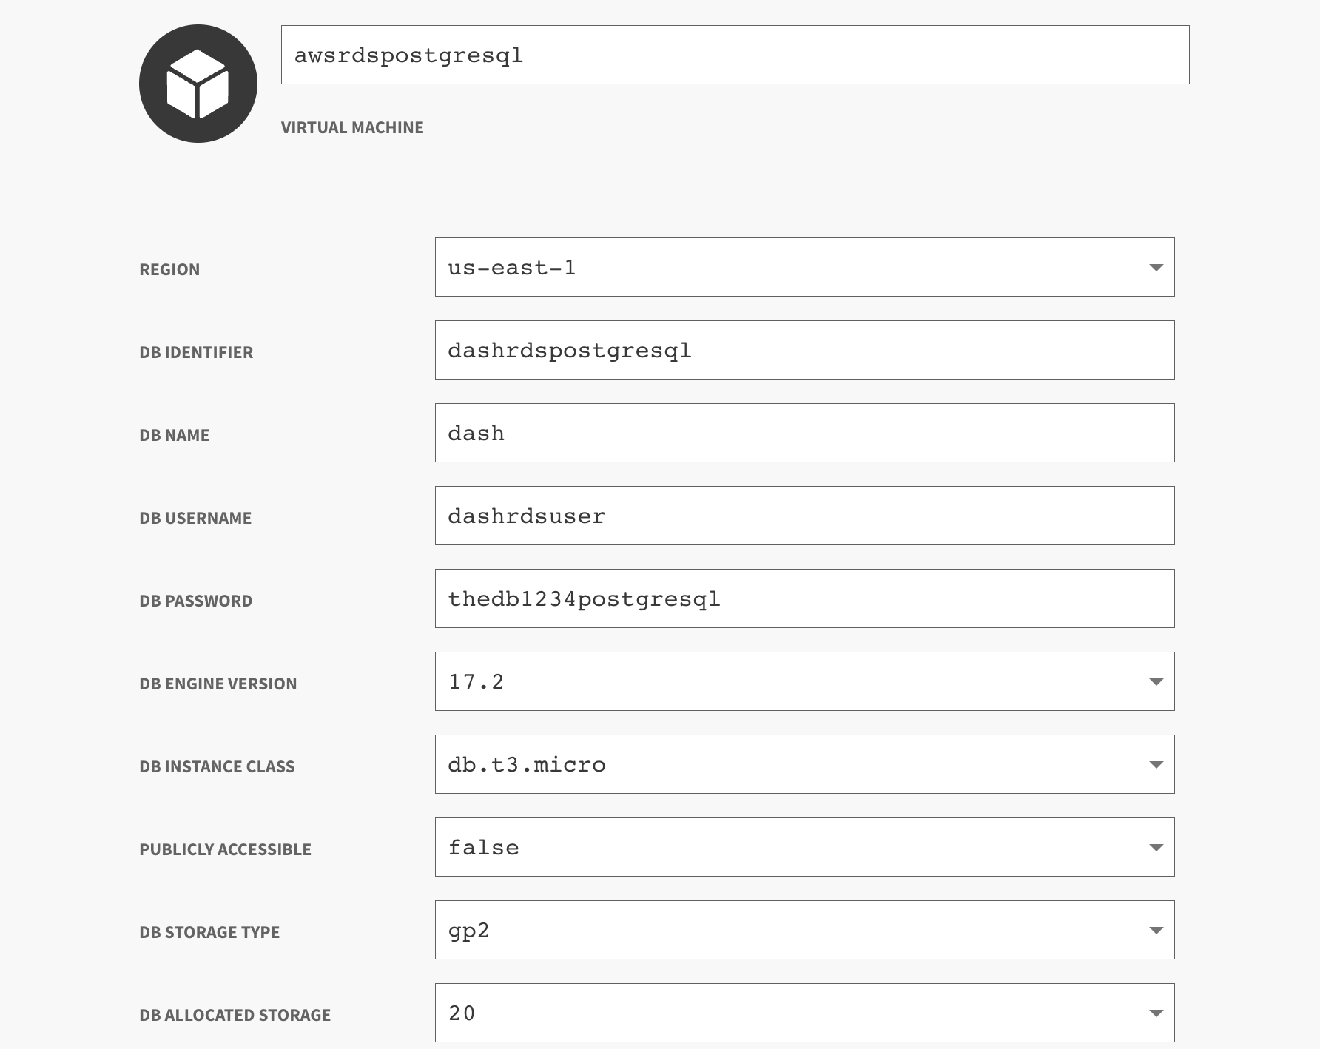
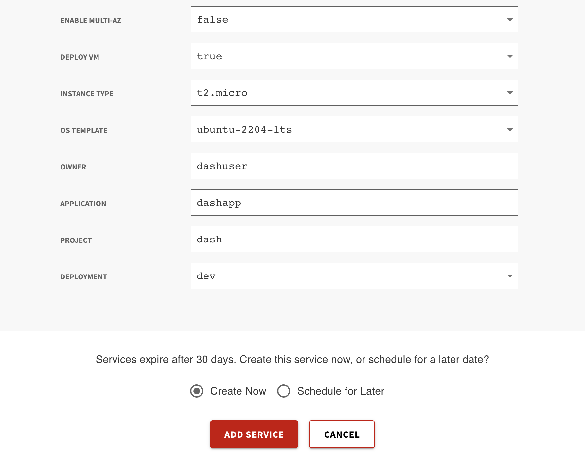

Output Guide:
This section outlines the output values generated after AWS RDS PostgreSQL provisioning through the DASH Portal. These outputs can be used to access, manage, and connect to your PostgreSQL Database.
Outputs | Description | Example Value
endpoint | The database endpoint used to connect to the DB instance. | dashrdspostgresql.czeq0oqa6rxx.us-east-1.rds.amazonaws.com
postgres_connection | The PostgreSQL connection string includes endpoint, username, database to connect to the DB. | psql -h dashrdspostgresql.czeq0oqa6rxx.us-east-1.rds.amazonaws.com -U dashrdspostgresuser -d dash
public_ip | The public IP address of the provisioned EC2(if enabled). | 13.217.28.84
ssh_password | The password associated with the SSH username for EC2 access. | IJoqGUeo
ssh_username | The username to connect to the EC2 via SSH. | dash

Note: If deploy_vm is set to false in the input, the output will only include the endpoint and postgres_connection.

What you can do with these outputs:

1. When publicly accessible is enabled:
You can connect directly to the DB endpoint.

psql -h <endpoint> -U <db_username> -d <database>

Example: psql -h dashrdspostgresql.czeq0oqa6rxx.us-east-1.rds.amazonaws.com -U dashrdspostgresuser -d dash
When prompted, enter the value of db_password (which you provided in the input) to connect to the database.

2. When publicly accessible is disabled:
You must first connect to the EC2 and then access the DB from inside it.
Step 1: SSH into the EC2
Example: ssh <ssh_username>@<public_ip>
Replace <ssh_username> and <public_ip> with the values generated in the outputs. When prompted, enter the value of ssh_password to login to the EC2.
Step 2: Connect to the DB engine from the EC2
psql -h <endpoint> -U <db_username> -d <database>
Example: psql -h dashrdspostgresql.czeq0oqa6rxx.us-east-1.rds.amazonaws.com -U dashrdspostgresuser -d dash
When prompted, enter the value of db_password (which you provided in the input) to connect to the database.

